School Year Session Rollover Process
Outline Checklist:

- Step 1: Check school session start date and grade settings.

- Step 2: Create a backup before beginning the rollover.

- Step 3: Conduct the Rollover from the CURRENT school session.

- Step 4: Clone the routes from the previous school session.

- Step 5: Clone Transportation Plans from the previous school session.

- Step 6: Remove graduated students from routes in the NEW school session.

- Step 7: Adjust the bus schedules for students whose school change affected transportation. (EX. Elem to Middle, Middle to High, etc.)

- Step 8: Final Clean Up: Route all unrouted students who did not get routed with Auto Assign.

You can print this page to use as a checklist if you are already familiar with the rollover process.

Step 1: Check School Start Date and School Session and Grade settings.
To begin a new school year, the Travel Tracker has a rollover process that will assist in rolling over students to the new grade. |  | **THIS EXAMPLE ASSUMES ROLLING OVER FROM 2023-2024 to 2024-2025.
Example:
Current Year/Semester = 2023-2024 Year/Semester = 2024-2025
Before starting this process, we’ll need to set up your new School Session and check your feed grades and schools. | 
Click on the General settings drop-down and select ‘School Years & Sessions’ | 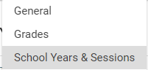  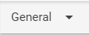
Setup your School Session for the coming year if not already in  the list. If they are in the list, check the dates and adjust if needed. Use the “+” icon to add new School Sessions if needed. | 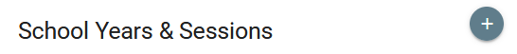  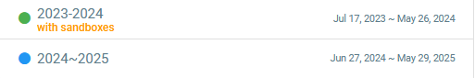
When you add a School Session, use the actual calendar year. The school year will calculate and display when you click Save.  Click Save to save the School Session. | 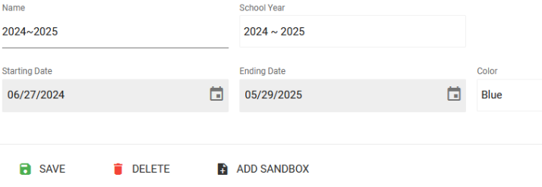
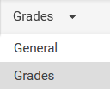  Click on the Grades option in the drop-down filter.  Double check grades to make sure they are in the correct sequence.  *While in the Grades sections, this would be a good opportunity to review your walking distance for each grade to make sure they are correct. | 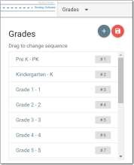  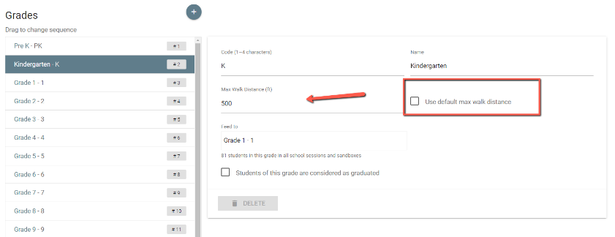

Step 2: Create a backup before beginning the rollover
You may want to make a backup of the database before starting the rollover. To do so, go to the Profile in the upper right and select Backups. | 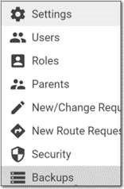
Click on the Add button. | 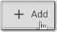
Name the backup and click on Save. | 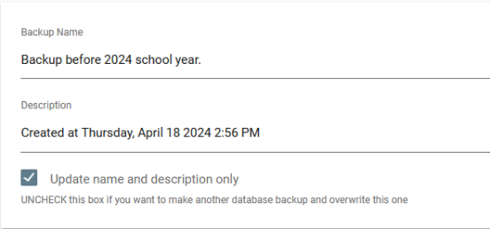  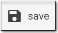

Please Read Before Continuing with the Next Step:
The following is important information and directions about what to do in the next steps depending on where your SIS is. Please read carefully.

No nightly updates into your system from your SIS system: Follow steps 3-7.
Nightly Updates from your SIS, and your SIS has not rolled over: Follow steps 3-7.
Nightly updates from your SIS, and your SIS has rolled over: Skip step 3, continue with steps 4-7
Note: The system compares the file that comes through nightly to what is already in the system. Once your file has >50% of students with a grade change, it will start syncing to the upcoming school year. This will correct any incorrect grades for students who did not advance or any incorrect schools for districts with multiple feed schools.

Step 3: Conduct the Rollover from the CURRENT School Session
IN THE UPPER RIGHT CORNER,
MAKE SURE YOU ARE IN THE CURRENT SCHOOL YEAR BEFORE YOU DO THE ROLLOVER!
Click on the Students tab. Click on Operations and then Rollover. | 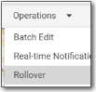
Verify the feeder schools. If any of these are incorrect, *Stop and go to the schools tab and edit the school to set the correct feeder. (See below for instructions)  The list below will show all students and the next grade that will be indicated for the student. | 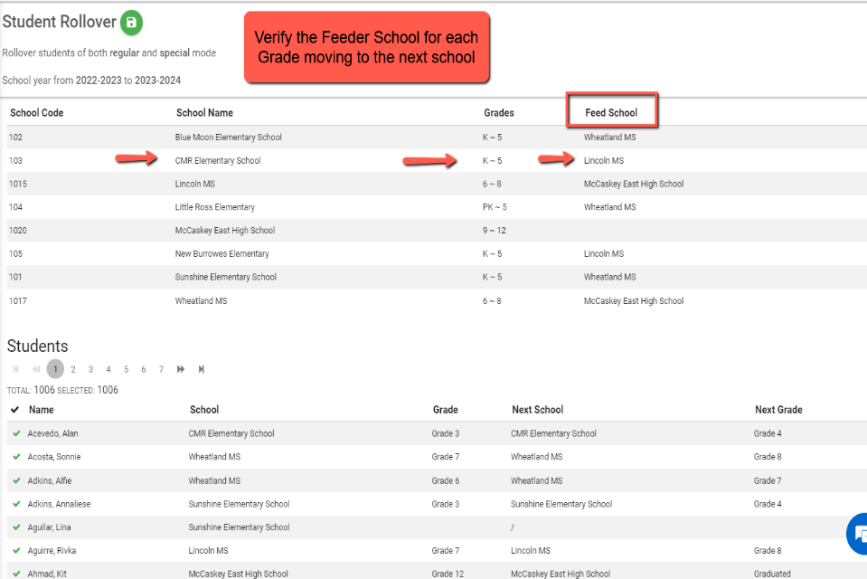
*To correct Feeder Schools if they are not correct, go to the schools tab and edit to select the correct Feeder* Then return to Student Tab and Select Operations and then Rollover as shown above. | 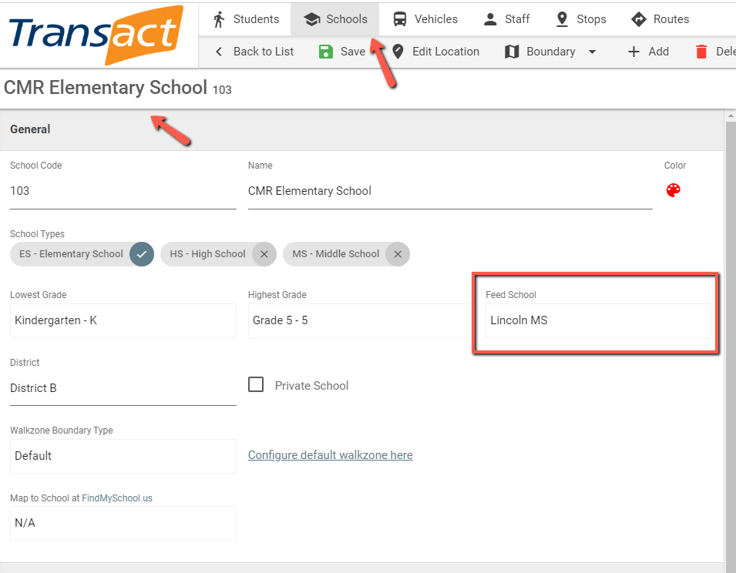
Click on the green save icon. | 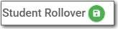
Click Yes to continue | 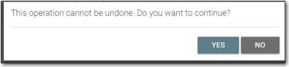

Step 4: Clone the routes from the previous School Session
After the rollover, you will need to clone the routes from the CURRENT school session into the NEW school session
Make sure you are still in the current session before cloning.
Go to the Routes tab,  Operations, and choose Clone Routes | 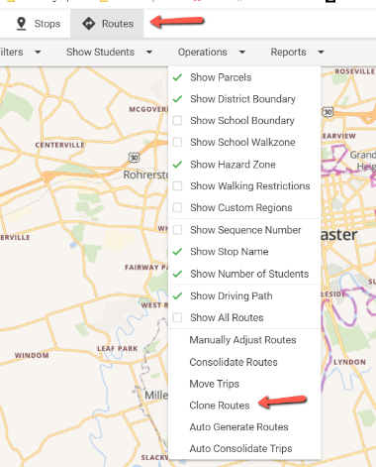
Select which school session to clone the routes to (2023-2024)  Click on Select All to check all routes, and then click on the Clone Routes button. | 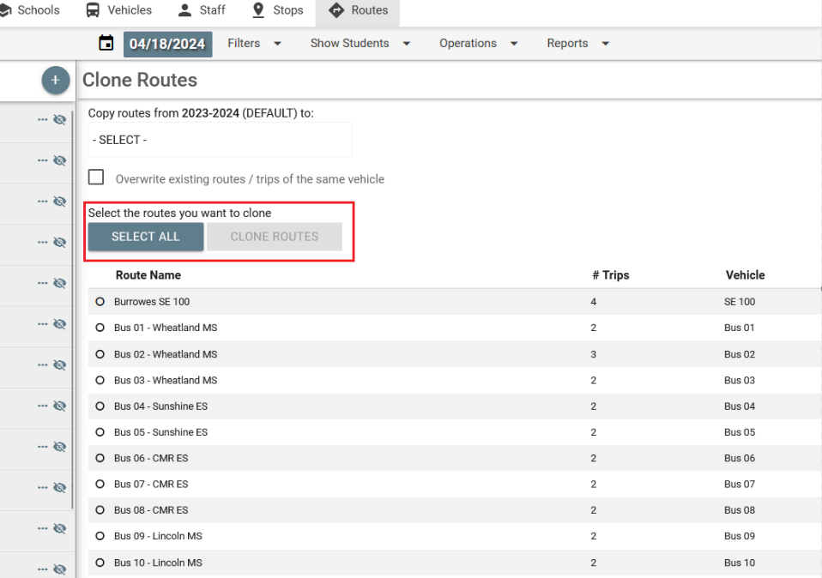
Click Yes to confirm. | 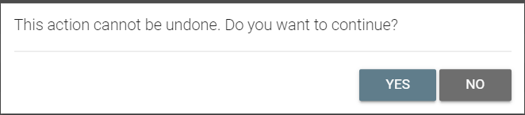

Step 5: Clone Transportation Plans from the previous School Session (You will need to do this step even if your district does not currently use Transportation Plans. This will allow you to use the Auto Assign feature to re-route your students with a school change in an upcoming step)
From the Students tab (in the current school session 2023-2024), click on Operations, and choose Batch Edit | 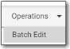
Under “Transportation Plans,” select “Remove All.”  Then, click the green “save” button at the top of the Batch  Edit page  We will regenerate these in just a moment in an upcoming step.  They will be generated from your current bus schedules. | 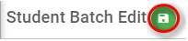  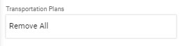
Once you click save, go back into the Batch Edit tool. | 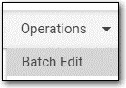
Under “Transportation Plans,” select “Regenerate transportation plans from bus schedules” and click the green save button at the top of the Batch Edit page.  Note: This step ensures that transportation plans match the correct bus schedules for routed students. | 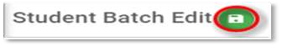  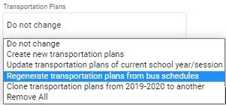
Go back to the Batch Edit tool one more time.
Under Transportation Plans select “Clone transportation plans” then select “Clone to 2024-2025”. Click on the green save button. Click Yes to confirm. This will take a few minutes to run. | 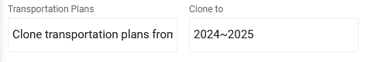  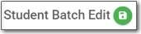  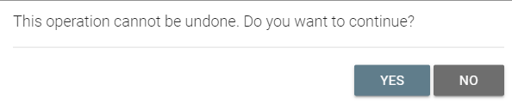
Step 6: Remove graduated students from routes in the NEW School Session
SWITCH TO THE NEW  SCHOOL SESSION IN THE UPPER RIGHT | 
We will want to first remove the graduated students from the routes in the New School Session. Click on the  Students tab, Filter for Grades and selected Graduated | 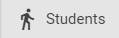  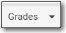  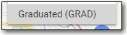
Click on Operations, Batch Edit | 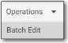
Under Bus Schedules, select  “Remove All.” This will remove all bus assignments for graduated students.  Click the Green Save button  Click Yes to continue. | 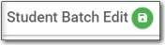    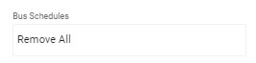

Step 7: Adjust the bus schedules for students whose school change affected transportation (EX. Elem to Mid and Mid to High, etc.)
For students who moved from Elementary to Middle schools and from Middle to High Schools or any other situation where the rollover created a school for a grade promotion, you will need to locate those students and adjust their bus schedules You will want to start with the Middle schoolers that moved to High school before doing the elementary to middle students, so that you can ensure spaces on buses for elementary to middle students and new kindergarteners.

REMEMBER TO STAY IN THE NEW SCHOOL SESSION
Under the Vehicles tab, check your vehicles to make sure none of them have zero (O) capacity. Otherwise, this will cause problems when you try to auto assign students.  To quickly see bus capacities:  Click the Report drop down and select the Vehicle Summary Report.  The capacities will show.  If any show 0, edit the vehicle,  and update the capacity.  Don’t forget to Click Save | 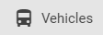  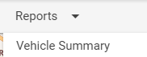  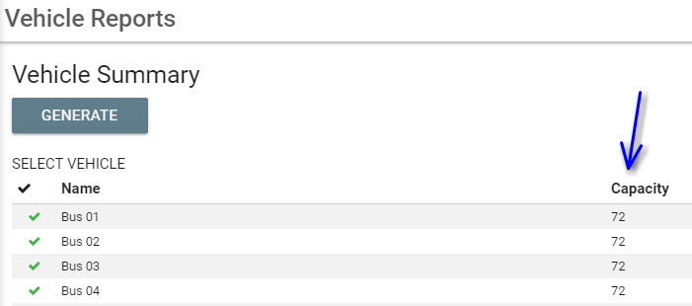  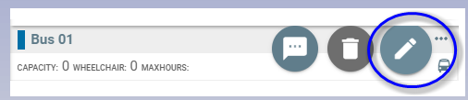  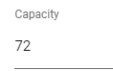  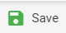
Go to the Students tab  filter on Grades  Select 9th grade (or the grade that moves to High School at your district).  Then select Filters, Riders, All Riders | 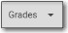  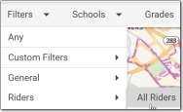  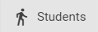
Click on Operations
Batch Edit
Under  ‘Bus Schedules’  Select ‘Remove All’  Click on the green save icon. | 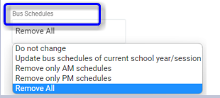

NOW WE WILL ROUTE THE 9th  GRADERS TO THEIR NEW ROUTES.  You should still be on the students tab and be filtered for 9th graders and add the filter with Transportation Plans.  Go to Operations  Click Auto Assign | 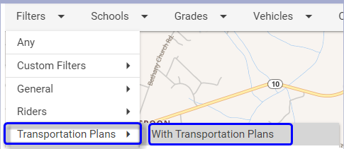  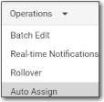
Click Search Assignments.  This will search for those students that can be routed using existing trips based on their transportation plans.  Review the assignment suggestions.  If they look correct,  Click Save Assignments. |   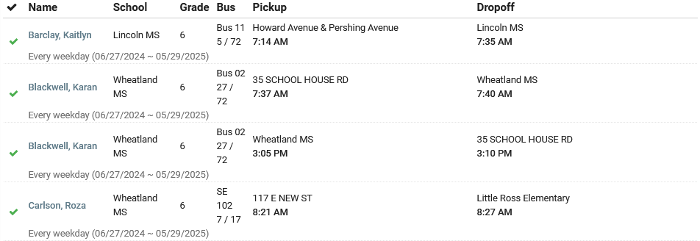  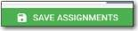
You may have students who are not routed automatically because their previous stop is not currently on a route going to their new attending school.  To see the 9th Grade students that didn’t get routed:  Go to Filters,  Transportation Plans  With Transportation Plans  Then go back to Filters,  and choose Bus Schedules  Unrouted  To verify the filtering is correct, click on the magnifying glass in the search bar.  This should be showing:  Grade 9  With Transportation Plans  Unrouted | 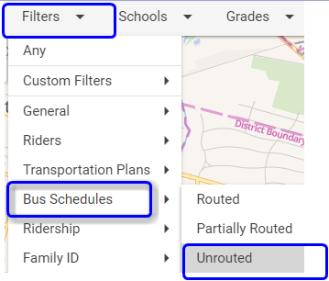  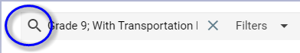  
***Repeat step 7 for other grades that moved schools (for example from Elementary to Middle).

Step 8: Final Clean up-Route all Unrouted Students who did not get routed with Auto Assign.

To route the unrouted students that were previously routed and that did NOT auto assign, use the routing techniques you are already familiar with using.
Note: To identify all Students that were routed in the previous school session that did not get auto assigned, you can identify these by filtering for Transportation Plans and Unrouted students | 

