Travel Tracker Routing: How to Start Navigation on a Tablet

- Turn on tablet. If your tablet is not already on. Press and hold
the top right button until the screen lights up.
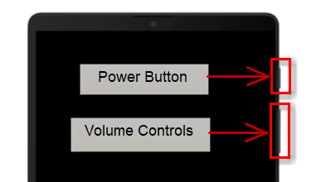

- Open up SafeDriver360 App:
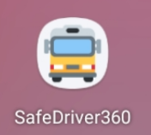

- Log in to SafeDriver360: Your login will either be your unique email and password, or you district will use a generic email ad password for all tablets. You may need to ask your TD which is the case for your district.
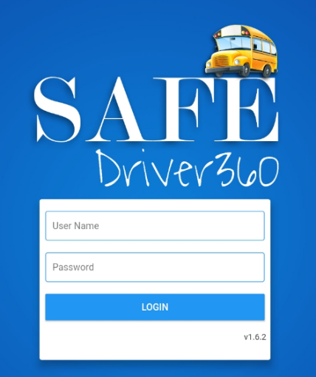

- The tablet may automatically put you on the Route Builder screen. You can tell what tab you are on in the app by looking at the bottom of your screen. Whatever tab you are on is highlighted in bright blue lettering.
Make sure that you are on the “Run-a-Trip” tab. The “Run a Trip” icon should be highlighted in blue, and you should see a map on the screen, as well as a few drop-down for selecting the route you want to run.

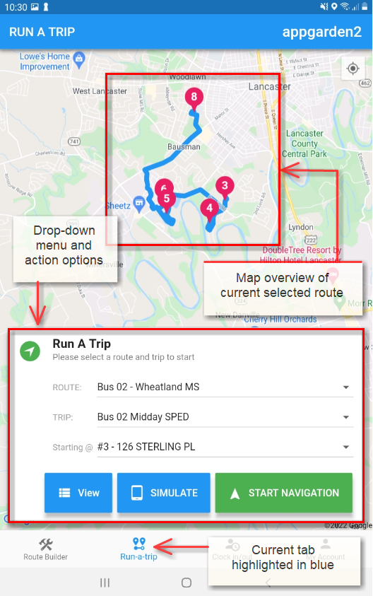

- Select the route and trip you want to run, click “start navigation.”
Note: Depending on how your district set up tablet access, you may only have access to the route assigned to your vehicle. In other cases, you may have access to all routes in your district. For accurate mileage tracking and student assignments, make sure that you’ve selected the corrected route and AM or PM run.
